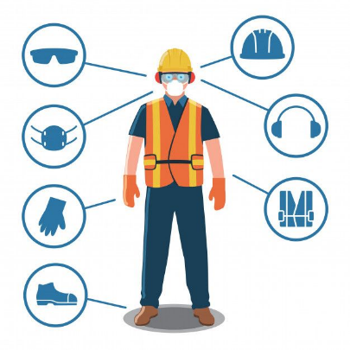

* Distanced
* Maintenance
* Sharp objects
* Toxic fumes

**Risk and Safety**